How to Get Into Investment Banking: The 8-Step Undergrad Roadmap
Meta description: How to get into investment banking as an undergrad: eight steps in the order they come due, from freshman GPA to the Summer 2028 application and return offer.

Getting into investment banking as an undergrad means landing an Investment Banking Summer Analyst seat for the summer before senior year, then converting it into a full-time offer. Goldman Sachs accepted fewer than 1 in 100 of its intern applicants in 2026, the third year in a row below 1 percent. [VERIFY: Fortune, June 8, 2026] The seat is decided in sophomore year: Summer 2028 applications opened at elite boutiques in September 2026 and are expected at bulge brackets in December 2026 and January 2027. [VERIFY: bulge-bracket opening months once posted]

In this article, I lay out how to get into investment banking in eight steps, in the order they come due, from freshman fall to the full-time offer, with the dates that matter for the Class of 2029.

How hard is it to get into investment banking?
Very hard by the numbers, and a process rather than a lottery. Goldman Sachs took about 2,600 interns from more than 360,000 applicants in 2025, a 0.7 percent rate, and stayed under 1 percent in 2026 with a class of about 2,500. [VERIFY: Fortune, June 2025 and June 2026] Bank of America's head of talent told Business Insider the bank received about 240,000 applications for fewer than 2,000 internships in 2026, about 0.8 percent, while Bloomberg reported roughly 315,000 applications for its internship and campus programs. [VERIFY: both secondhand; the two reports conflict] Those rates cover every intern track at the bank, not banking alone. What makes it a process is that the same handful of inputs decide most outcomes (grades, one club number, a program, a network, a resume, the technicals, and the day you apply), and each one has a date. We covered what weighs most in How Hard Is It to Get Into Investment Banking?. This article is the order to do it in.

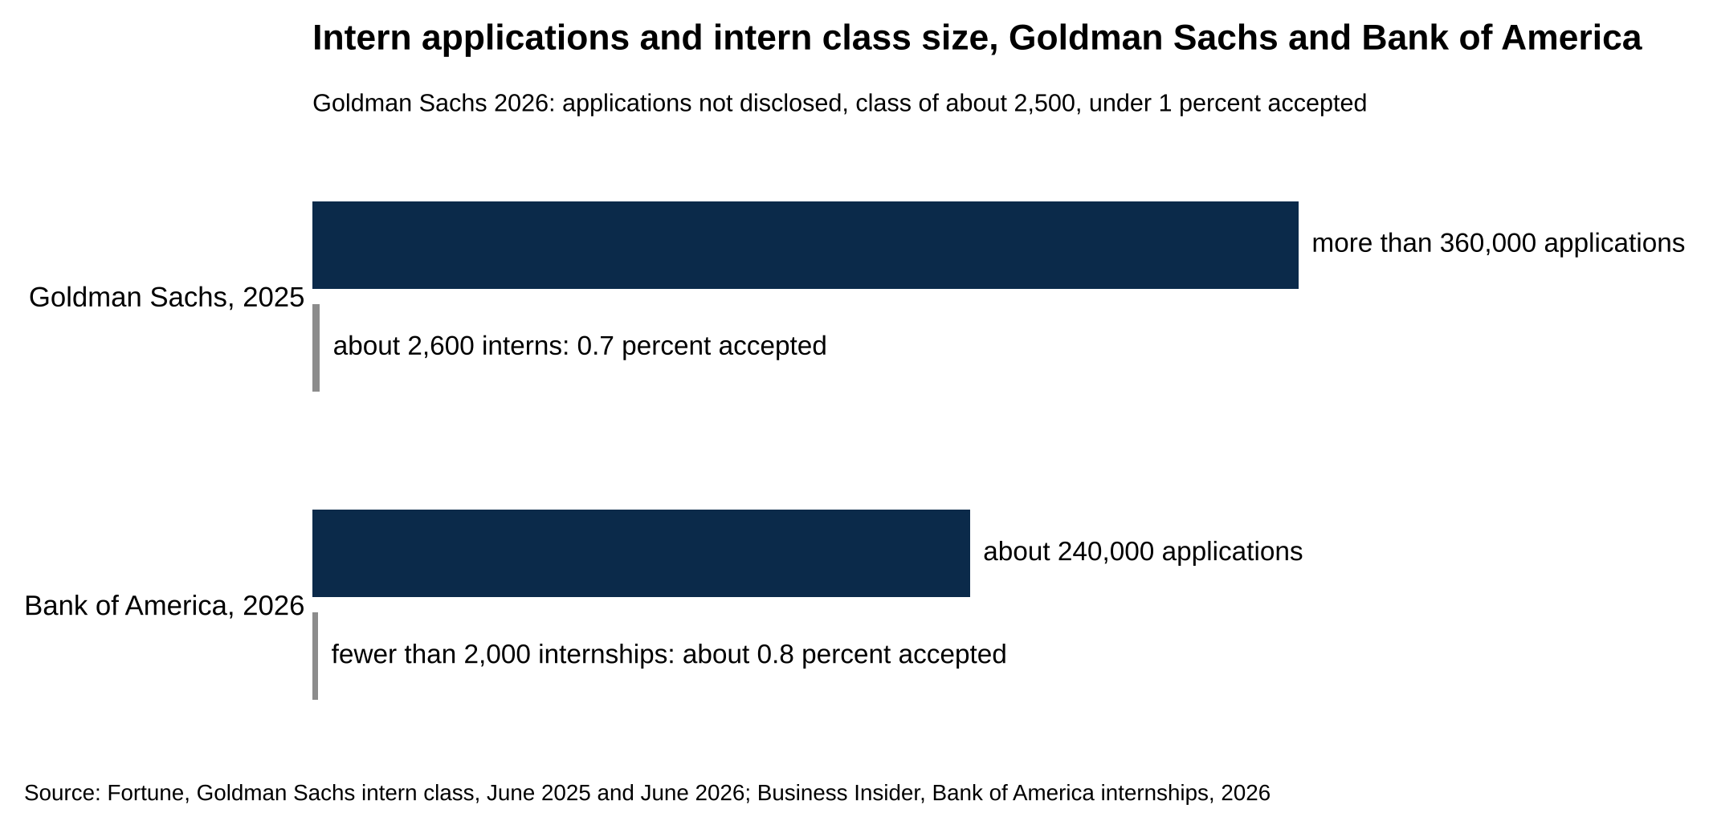
Goldman Sachs accepted 0.7 percent of intern applicants in 2025 and Bank of America about 0.8 percent in 2026.
Source: Fortune, Goldman Sachs intern class, June 2025 and June 2026; Business Insider, Bank of America internships, 2026.

Do you need to go to a target school to get into investment banking?
No. Goldman's 2024 intern class came from more than 475 schools, and Bank of America's 2026 class of interns and campus hires came from more than 500. [VERIFY: Fortune June 2025; Bank of America newsroom June 3, 2026] College Transitions counted nearly 10,500 entry-level Investment Banking Analysts at 16 banks on LinkedIn. NYU led with 386, Michigan had 296, Cornell 279, and Baruch, a public college in Manhattan, placed 168 analysts, 11th on the list. The bar is higher from a non-target. Mergers & Inquisitions puts it at near-perfect grades, a 3.8 or higher, and says bankers may be skeptical of a 3.5 from a lesser-known school. The steps to break into investment banking from a non-target are the same eight, and the volume is higher: Mergers & Inquisitions budgets 1,000 to 2,000 networking emails from a non-target against a few hundred from a target.

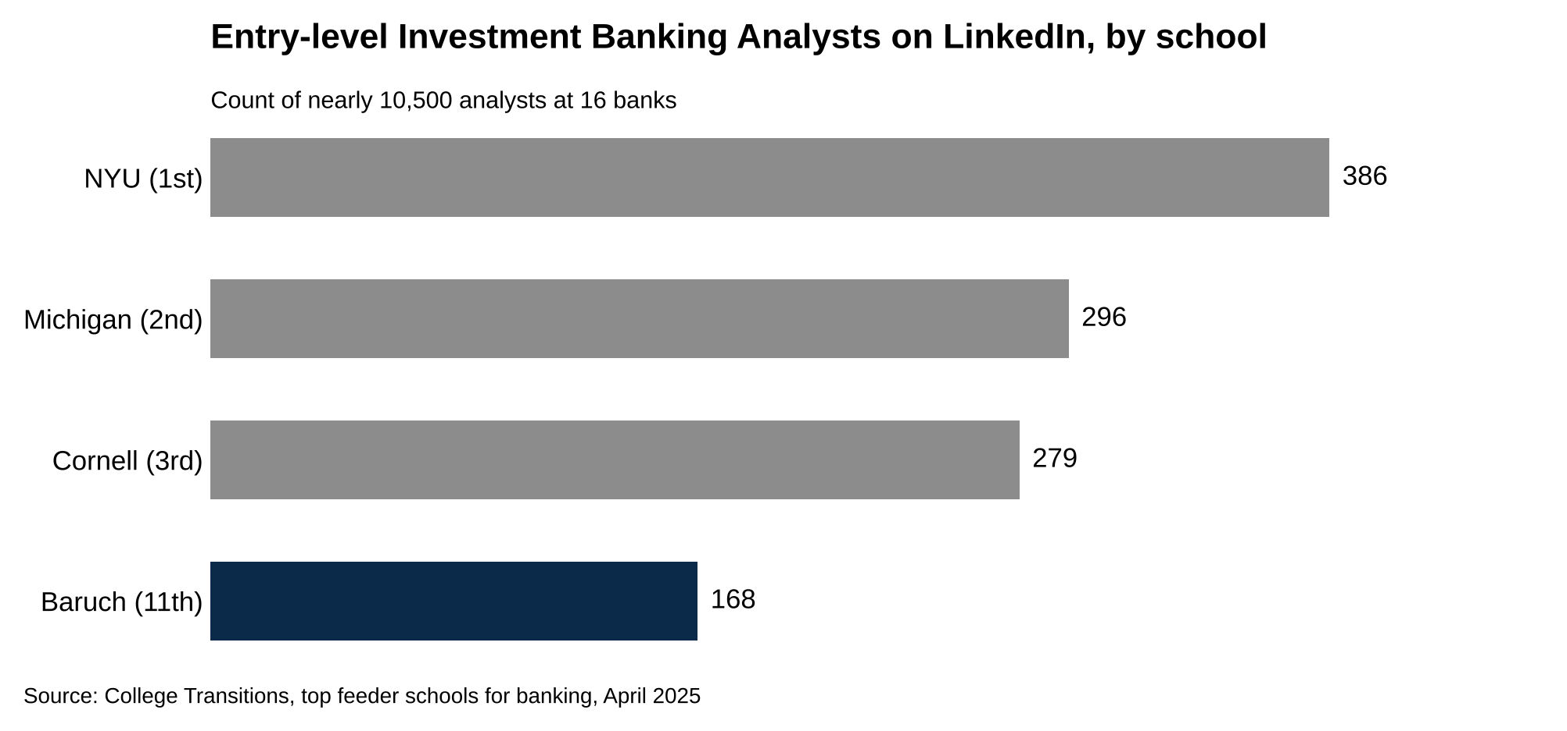
NYU leads with 386 analysts, and Baruch, a public college, places 168, 11th on the list.
Source: College Transitions, top feeder schools for banking, April 2025.

How to get into investment banking in eight steps
The roadmap runs in the order the steps come due, not in order of importance. Steps 1 and 2 belong to freshman year. Steps 3 and 4 start the summer after freshman year and run through sophomore fall. Steps 5, 6 and 7 land in sophomore fall and winter, when the resume, the technicals and the applications come due within weeks of each other. Step 8 is the internship itself, the summer before senior year.

For a sophomore now (Class of 2029), the first four steps should already be underway, and the next three come due between October 2026 and February 2027. If you're a freshman (Class of 2030), you have a year of runway, and every date below moves forward about a year for you. Each step says what to do, the evidence it works, and when it's due for each class.

1. A GPA above 3.5 is the first filter, so protect it early
Bank of America's Investment Banking postings list a 3.5 as "preferred" (3.2 for its Strategy & Management track). [VERIFY: current Bank of America posting language] Goldman Sachs publishes no minimum on its summer analyst postings. Mergers & Inquisitions says a candidate from a non-target school needs "perfect or near-perfect grades (3.8+ GPA)," and that bankers "might be skeptical of a 3.5 GPA from a lesser-known school."

"Preferred" is the word to read carefully.

A 3.4 doesn't automatically bounce an application at Bank of America, because preferred isn't required. It does mean the other lines on the resume have to carry more weight, and a sophomore's resume has only a few lines to carry anything.

Bank of America lists a 3.5 GPA as preferred for Investment Banking, and Mergers & Inquisitions puts the bar for a non-target school at 3.8 or higher. [VERIFY: both figures]

Freshman grades are most of the GPA a bank sees, because of the calendar. When Summer 2028 applications open at bulge brackets in December 2026 and January 2027 [VERIFY: opening months once posted], a Class of 2029 sophomore has two full semesters of grades on the transcript and a third in progress. A 3.9 freshman year leaves room to take the harder accounting and finance classes in sophomore fall. A 3.2 freshman year can't reach 3.5 by the time the portals open, even with a perfect sophomore fall: two semesters at 3.2 and one at 4.0 average 3.47. So the move in freshman fall is plain. Take a course load you can hold a 3.7 or better in. Take intro accounting as early as the school allows, because it feeds step 6. Treat the first two semesters as the part of the transcript applications will actually show.

If the number lands under 3.5 anyway, two things help. Put the major GPA on the resume next to the cumulative one when it's higher, and make steps 2 through 4 heavier than a 3.8 student would need to, because the fund pitch, the program and the referral are what carry a 3.4 past the screen.

For the Class of 2030, this semester is the one that counts most. For the Class of 2029, the number is mostly set; a strong sophomore fall still moves it. The year-by-year version of this plan, including what to take when, is in our Freshman to Junior Roadmap.

2. Join one finance club and produce one number from it
A club membership on a resume is a label. A number from a club is evidence. "Member, Investment Club" tells a screener nothing. "Pitched a long position to a $700,000 student fund, and the fund took the position" tells them you've done a piece of the job.

The point of the club is the number.

The clubs that produce numbers are student-run investment funds and research competitions. Penn State's Nittany Lion Fund manages more than $10 million for accredited investors, is run by 40 undergraduates each semester, and says it has placed more than 350 alumni into financial institutions since 2005. [VERIFY: fund page figures] Michigan Ross's Maize & Blue Fund runs a $700,000-plus slice of the university's endowment in pitch teams of three or four students, each led by a senior analyst. [VERIFY: fund page] The CFA Institute Research Challenge puts teams of three to five students to work writing a full equity research report on one public company and presenting it to judges, scored on analysis, valuation, report writing and presentation. It runs at local, regional and global levels every year, with the next global final in May 2027. [VERIFY: 2027 final date]

Every one of those produces a line with a number in it: the size of the fund, the position you pitched, how the position did, where the team placed.

If your school has no fund, the number comes from a pitch you write yourself. Pick one public company. Write three pages: what the business does and how it makes money, why you think the market has the price wrong, a simple valuation (at this stage, comparing its price-to-earnings ratio with a few similar companies is enough), the two biggest risks, and a target price. Then defend it for ten minutes to anyone who'll listen, ideally a banker from step 4. That's the same work a fund analyst does, and it fits on one resume line: the company, the thesis and the number you landed on.

One pitch in a student fund or a research competition gives a freshman resume its first real number, and it's the line a banker can ask about for ten minutes in an interview.

Class of 2030: join this fall and have a pitch finished by spring, so the line is on the resume before the summer emails in step 4 begin. Class of 2029: you need the number on the page before December, and one pitch this semester, finished and dated, is enough. If the resume is blank right now, the nine fixes in How to Get Into Investment Banking With No Experience are built for exactly that.

3. Apply to freshman and sophomore programs, because they're the earliest door
The banks run short programs for first-years and sophomores, from a single insight day to a five-week paid summer, and several of them feed straight into Summer Analyst interviews. Moelis says its Leadership Development Program gives sophomores "an opportunity to interview for our US Summer Analyst Intern Program." Citi's Early Identification program includes "interview preparation for Summer Analyst roles." Barclays says Discovery Programme participants "may be considered for" an internship. Morgan Stanley's Early Insights listing says the other side plainly, that participation "does not guarantee selection for the summer analyst program," which is the right way to read all of them: the program gets you the interview, and the interview still has to go well. Prospect Rock, a prep firm that tracks these programs, says participants "routinely" get accelerated interviews, and no bank publishes the share. [VERIFY: program language on each firm page]

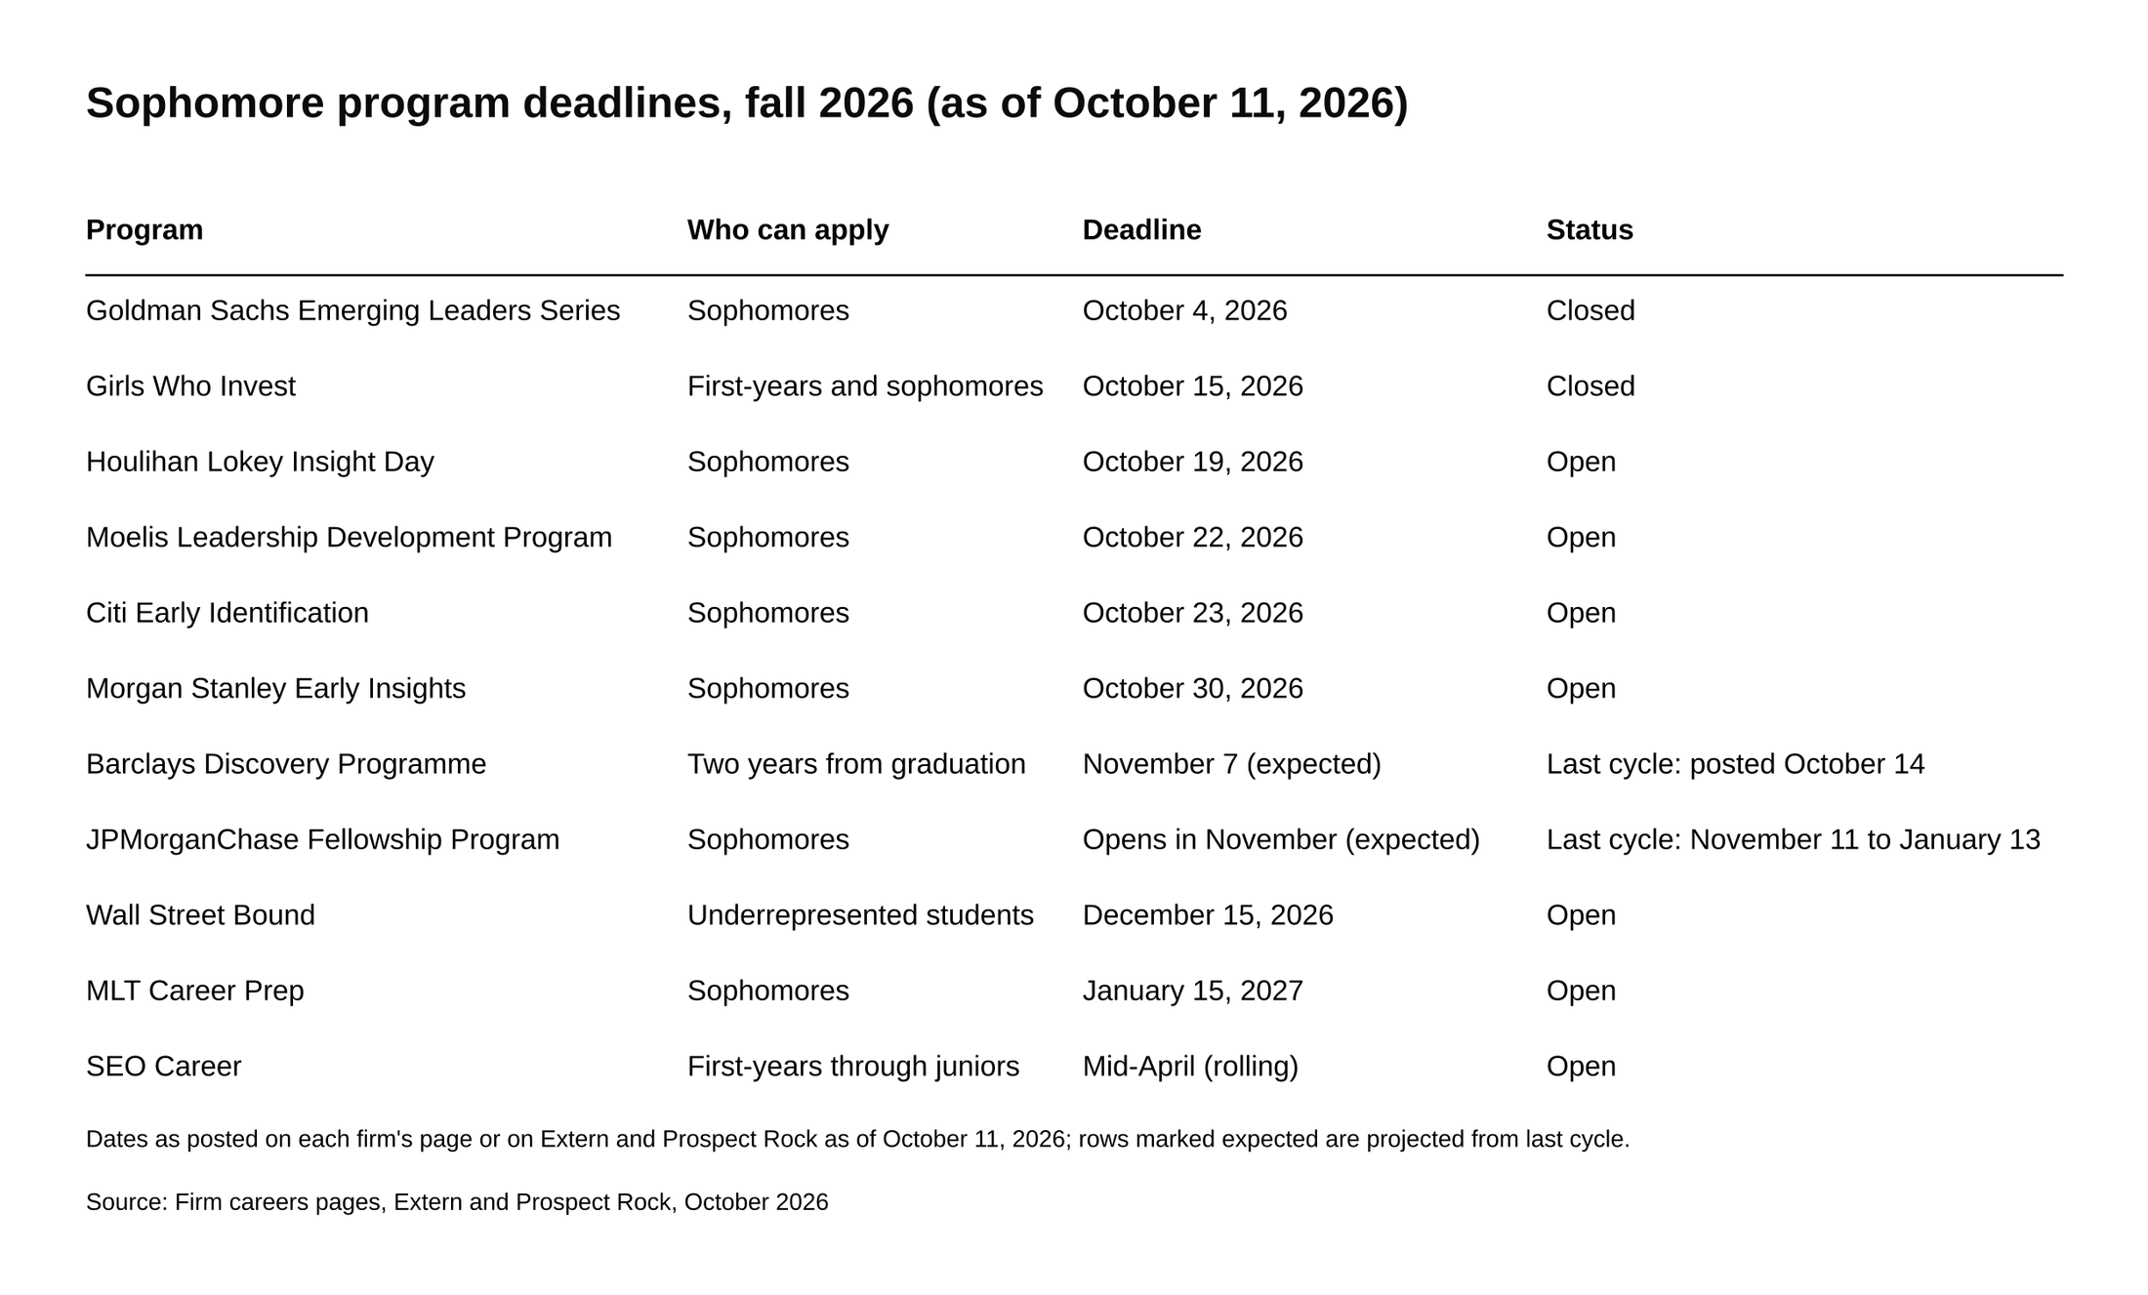
Four sophomore programs close between October 19 and October 30, 2026, and two expected windows follow in November.
Source: Firm careers pages, Extern and Prospect Rock, October 2026.

Moelis says its Leadership Development Program gives sophomores an opportunity to interview for its US Summer Analyst program, and this year's deadline is October 22, 2026. [VERIFY: Moelis page and Extern]

For a Class of 2029 sophomore, most of the fall 2026 list is due in the next three weeks:

- Houlihan Lokey Investment Banking Insight Day: apply by October 19, 2026, for sessions in New York or Chicago. [VERIFY: Extern, October 9, 2026; session dates not on the firm page]
- Moelis Leadership Development Program: October 22, 2026. [VERIFY: deadline]
- Citi Early Identification: a three-week virtual program, 2 to 3 hours a day, for US sophomores in a four-year degree; the current round closes October 23, 2026, and Citi's page says applications open in November and February for December and March cohorts. [VERIFY: Extern for the October 23 date; Citi page for the cohort months]
- Morgan Stanley Early Insights: for sophomores graduating December 2028 to June 2029; registration closes October 30, 2026, with virtual sessions on November 2 and 5. [VERIFY: Morgan Stanley careers page]
- JPMorganChase Fellowship Program: a five-week paid, full-time summer fellowship for sophomores with Investment Banking and Global Markets tracks, run with the firm's Office of Black Affairs and Office of Hispanic & Latino Affairs and open regardless of background; the last window ran November 11, 2025 to January 13, 2026, so expect it to open in November. [VERIFY: 2026 window]
- Barclays Discovery Programme: a two-part workshop series for students two years from graduation; the last US cycle posted October 14 with a November 7 deadline. [VERIFY: 2026 posting]
- Goldman Sachs Emerging Leaders Series: the sophomore program, open to all, with an Investment Banking track in New York and a run from fall 2026 to spring 2027; this cycle closed October 4, 2026. [VERIFY: next cycle]

Then the pipeline programs, which run outside the banks and feed many of them at once:

- Girls Who Invest: first-years and sophomores, any major; four weeks of training at Wharton plus a seven-week paid internship at one of 130-plus partner firms, or an asynchronous online program; the final deadline for 2027 was October 15, 2026. [VERIFY: next cycle]
- MLT Career Prep: sophomores graduating fall 2028 to summer 2029, US citizens, permanent residents or DACA recipients; 20-plus months of coaching; final deadline January 15, 2027; MLT says 90 percent of its fellows get full-time offers before graduation. [VERIFY: deadline and figure]
- SEO Career: first-years through juniors, 3.2 GPA (3.0 considered), US work authorization; rolling, and the "Success Class typically closes in mid-April"; SEO says more than 80 percent of its interns get full-time offers. [VERIFY: figure on the apply FAQ]
- Wall Street Bound: a free four-month program for underrepresented students; apply by December 15 for the January 2027 cohort. [VERIFY: deadline]

For the Class of 2030, the first-year doors are the Goldman Sachs Possibilities Series (last deadline March 1, next cycle expected early 2027), Citi's Freshman Discovery (three days, virtual, applications open in late March or early April), Girls Who Invest, and MLT Ascend, MLT's one-year track for low-income or first-generation college freshmen. [VERIFY: 2027 dates] The sophomore list above comes due for you in fall 2027.

Two notes on applying. Read each eligibility line rather than assuming: several of these are partnered with diversity offices or built around underrepresented students, and several of those are open to everyone. And apply to every one you're eligible for, because they close before the Summer Analyst portals open and the interviews they lead to come first. The full list with who each one looks for is in Top 10 Sophomore Insights Programs for IB, and the fellowship deadlines are in our diversity finance fellowships guide.

4. Cold email after freshman year, and expect one reply in ten
Networking in banking means informational interviews: a 10 to 15 minute call with a banker about their path and their advice, requested by a short email of five sentences or fewer. The call is not an ask for a job. The ask comes later.

The mechanics, from Mergers & Inquisitions' networking guide, look like this. Emails sent to the right people get a 10 to 25 percent reply rate. About half of the people who reply will take a call. So 100 emails produce 10 to 25 replies and 5 to 12 calls. The working numbers from Mergers & Inquisitions: gather 20 to 30 names at a time, aim for 2 to 3 calls a week, and expect to send a few hundred emails from a target school (its informational interview guide plans on 300 to 500 over about six months) or 1,000 to 2,000 from a non-target. Plan on the low end, one reply in ten, because the budget above is built for that and anything better is a bonus.

Mergers & Inquisitions puts the reply rate on well-targeted networking emails at 10 to 25 percent, with about half of the people who reply taking a call.

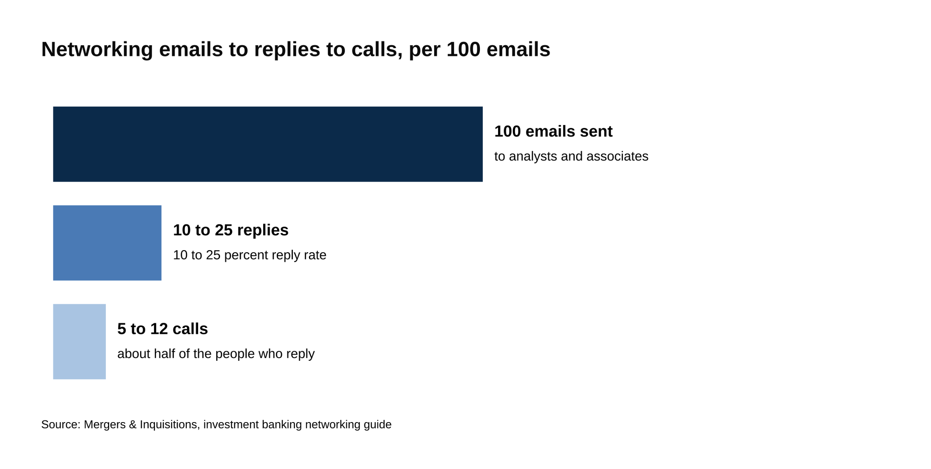
Every 100 emails to the right bankers produce 10 to 25 replies and 5 to 12 calls.
Source: Mergers & Inquisitions, investment banking networking guide.

Who to email: analysts and associates, not managing directors. Prospect Rock's recruiting guide says it flatly: "junior bankers respond at far higher rates than MDs." An analyst sat in your chair two or three years ago, which makes the call easier for both sides. Find them on LinkedIn with the school and company filters, starting with your own alumni, then widen to people who share a hometown, a major or a club.

The email itself is five sentences. Who you are (school, year, major). How you found them (alumni, a mutual contact, a panel they spoke on). One specific thing about their path you want to ask about (the group they chose, a move they made). The ask: 15 minutes on a call in the next two weeks, at their convenience. Thanks, and your name. No attachment on the first email. The resume comes when they ask for it or when you make the later ask.

After the call, send a thank-you the same day with one thing you took from it. Then 2 to 3 follow-ups over the following months, each with a reason to write: a question about something they said, a note that the program they mentioned accepted you, a note that you applied. The "mini-ask," in Mergers & Inquisitions' phrase, is one sentence at the end of the call or in a follow-up once the posting is live: would they be willing to pass your resume to the recruiter or the staffer, the banker who assigns analysts and interns to deals.

One contact per firm is the rule.

Centerview's careers page asks candidates not to email multiple people at the firm, and that instinct applies everywhere. Let one person pass you along rather than cold-emailing six people on the same floor.

Mergers & Inquisitions says to start 6 to 12 months before recruiting. For the Class of 2030, that's the summer after freshman year, summer 2027, with the calls running into sophomore fall. For the Class of 2029, the window is now: bulge-bracket portals are expected in December and January, so a list built this week gives you about eight weeks of calls before day one.

5. Build a one-page resume that reads in seven seconds
Recruiters spend about 7 seconds on the first pass of a resume (7.4 in Ladders' eye-tracking study), and the resumes that held attention had simple layouts, clear section headers, bold titles and bulleted accomplishments; clutter, multiple columns and long sentences lost it. A banking resume is one page, one column, four sections, for that reason.

What goes on a sophomore's page, top to bottom:

- Education: school, degree, expected graduation month and year, GPA to two decimals. The graduation line is what the portal checks against its eligibility window ("graduating December 2028 to June 2029" for Summer 2028 seats), so write it the way the posting does.
- Experience: the fund or club from step 2 first, with the number; then any job, paid or not, with what you produced.
- Programs and activities: the insight programs and fellowships from step 3, by name, with dates. Goldman Sachs Emerging Leaders Series is a line a screener recognizes on sight.
- Skills and interests: Excel, any modeling course, languages, and two interests you can talk about for five minutes.

Leave off the objective statement, the high school section once you have a college line to replace it, and anything you can't talk about for two minutes.

Each bullet is a verb, the thing you did, and a number. "Helped with stock pitches" becomes "Pitched a long position in [company] to a 40-member student fund; thesis adopted into a $20,000 position."

The second version can be checked and asked about. The first can't.

Every line on a banking resume carries a number, and for a sophomore the two lines that fill the page are the fund pitch from step 2 and the program from step 3.

Class of 2029: have the one-pager done by early November, because Evercore closes November 15 and the bulge-bracket portals follow in December and January; redo it each time a step adds a line. Class of 2030: build a first version this spring and rewrite it the summer before sophomore year, when steps 3 and 4 have added lines. The template, line by line, is in Investment Banking Resume: The One-Page Template That Gets Interviews, and the eight things screeners look for are in Investment Banking Internship CV: 8 Things Every Strong Application Includes.

6. Learn the technicals and five STAR stories before portals open
The technical interview has an order of priority, and the prep guides at Mergers & Inquisitions and Wall Street Prep agree on it: accounting first, then enterprise value against equity value, then valuation multiples and the three valuation methods, then the DCF, with M&A and LBO questions last. Prospect Rock adds that trading and transaction comps come up at almost every bank and "increasingly LBO fundamentals." Learn them in that order, because the interviews are weighted that way and each topic builds on the one before.

Accounting means the three financial statements and how they connect. The classic question is "walk me through a $10 increase in depreciation," and the answer is the mechanism, one statement at a time:

- Income statement: depreciation rises by $10, so pre-tax income falls by $10. At a 25 percent tax rate, taxes fall by $2.50 and net income falls by $7.50.
- Cash flow statement: start with net income, down $7.50. Depreciation is a non-cash expense, so add the $10 back. Cash from operations rises by $2.50.
- Balance sheet: cash is up $2.50 and PP&E is down $10, so total assets are down $7.50. Retained earnings fall $7.50 through net income, so equity is down $7.50. Both sides balance.

Enterprise value is the value of the whole business to everyone who funded it, debt holders and shareholders together. Equity value is what's left for shareholders after the debt is accounted for. The question that follows is which multiples pair with which: enterprise value with EBITDA, equity value with net income. The pairing works because EBITDA is earned before interest goes to the debt holders, so it belongs to everyone, while net income is what's left after interest, so it belongs to shareholders alone. The three valuation methods are comparable companies, precedent transactions and the DCF. A DCF projects the cash the business will throw off, discounts it at the blended cost of its debt and equity (the WACC), and adds a terminal value for the years past the forecast. We walk the full answer in Walk Me Through a DCF. M&A and LBO questions come last because they sit on top of all of that.

Behavioral questions get five stories: one about a team, one about a failure, one about a conflict, one where you led, and one where you turned data into a decision. Almost every behavioral question maps onto one of the five. Tell each in the Situation, Task, Action, Result shape, short enough to finish in under two minutes, with a number in the result. Thirty worked examples are in 30 Examples of Investment Banking Behavioral Interview Questions, and the sophomore-specific prep order is in The 2026 Investment Banking Interview Guide for Sophomores.

The reason to do this before the portals open is the speed of the first round. At most large banks the first round is a HireVue, a recorded video interview where you answer questions to a camera with no interviewer on the line. Goldman's version takes about 30 minutes, usually four to six questions with 30 seconds to prepare and about two minutes to answer each, and the invitation expires about a week after it arrives. [VERIFY: Goldman page for the 30 minutes; Leland, June 2026, for the question count; Extern for the expiry] Prospect Rock says the completion window across banks runs three to seven days. [VERIFY: Prospect Rock, July 2026]

Apply on a Monday and you may be recording answers by Friday.

A bank's first-round HireVue arrives with a three to seven day completion window, so the technicals and the five stories have to be ready before you submit the application. [VERIFY: window]

Free resources that cover all of it: Breaking Into Wall Street's free tutorials, Wall Street Prep's free resources hub with its seven free modeling lessons, the Wall Street Oasis interview database with more than 50,000 datapoints by firm and group, and Peak Frameworks on YouTube, run by Matt Ting, who worked at Evercore and Silver Lake. Our top 10 free resources post ranks them.

Class of 2029: now through December, with accounting and valuation first and the five stories written down by November. Class of 2030: the summer after freshman year, alongside the emails in step 4, so both are done before sophomore fall starts.

7. Apply the day a portal opens, because that's the real deadline
Most Summer Analyst portals are rolling. The bank reviews applications as they arrive, sends HireVues as it goes, and fills seats as superdays finish. Prospect Rock's line is "Your effective deadline is the day the portal opens," and it adds that posted close dates "are close to meaningless." Bank of America says the same in its own words: programs "will close as positions are filled." Evercore is the exception, with a fixed window and a review that isn't rolling, and its window still closes in November.

Here's what that looked like last cycle, for Summer 2027.

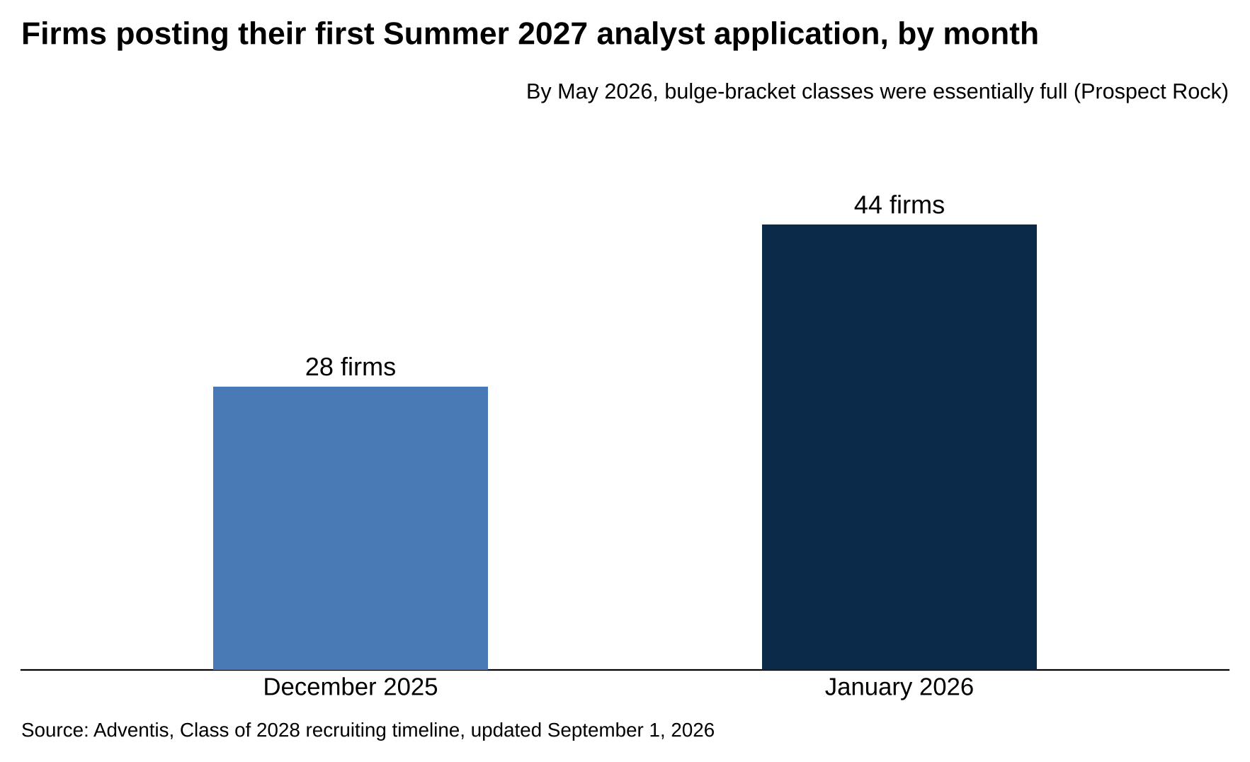
Adventis counted 28 firms posting in December 2025 and 44 more in January 2026.
Source: Adventis, Class of 2028 recruiting timeline, updated September 1, 2026.

Adventis, a tracker that logs each firm's first posting, counted 28 firms posting their first Summer 2027 analyst application in December 2025 and 44 more in January 2026. [VERIFY: Adventis, updated September 1, 2026] Morgan Stanley's US banking posting ran January 1 to February 15, 2026. [VERIFY: Extern] By May 2026, Prospect Rock reported bulge-bracket classes "essentially full." [VERIFY: Prospect Rock, July 2026] A student who applied in March was competing for whatever was left after the December and January applicants had already been through HireVues and first rounds.

Adventis counted 28 firms posting Summer 2027 applications in December 2025 and 44 more in January 2026, and Prospect Rock reported bulge-bracket classes essentially full by May. [VERIFY: both trackers]

For Summer 2028, the elite boutiques moved first. Evercore opened its New York generalist Summer 2028 application on September 9, 2026, closes it November 15, and lists eligibility as graduating December 2028 to June 2029. [VERIFY: Evercore job board] Evercore's first round is two live 30-minute interviews over Zoom or phone, with no HireVue. [VERIFY: Extern Evercore guide, October 2026] Harris Williams lists its window as October 2026 to January 2027, with interviews in early spring. [VERIFY: Harris Williams page] Moelis Houston is open to December 14, and Moelis says its US applications "typically open in the December of your sophomore year." [VERIFY: Extern] Bulge brackets are projected for December 2026 and January 2027. Extern expects Barclays and Deutsche Bank in late November, JPMorgan, Citi, Lazard and Jefferies in December, and Goldman Sachs, Morgan Stanley, Bank of America, UBS, Wells Fargo, PJT and Centerview in January 2027. [VERIFY: projections, not announcements] Goldman had posted no 2028 program in any region as of September 5, 2026, so January is a projection. Adventis lists Centerview as open at all times, and Centerview's page says it reviews one office per applicant.

What happens after you submit, at a bulge bracket: a resume screen, then the HireVue from step 6, then a first-round interview with one or two bankers, then the superday, which is the final round, several interviews back to back on one day. Goldman's own page says it runs "between two and five interviews for campus hires, depending on the division." Prospect Rock calls a typical superday four to six back-to-back sessions covering technicals, behaviorals and fit. [VERIFY: both] "Fit" is the part where a banker decides whether they'd want you on a deal team at 11pm, and it's where the five stories from step 6 do their work. Offers follow the superday, often within days.

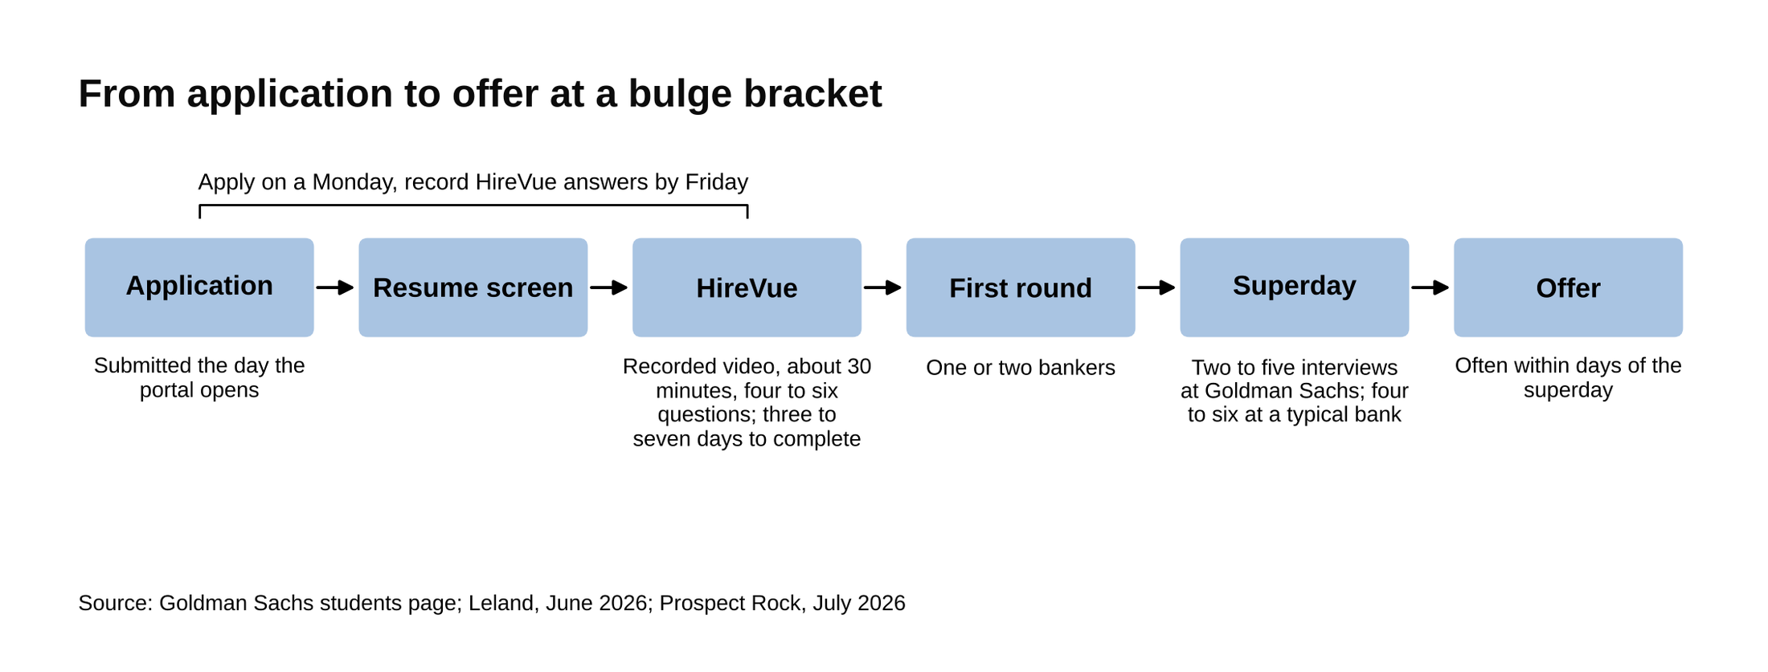
The HireVue arrives with a three to seven day window, and offers often follow the superday within days.
Source: Goldman Sachs students page; Leland, June 2026; Prospect Rock, July 2026.

The practical rule: have the resume and the stories done (steps 5 and 6), set alerts on each bank's careers page and on a tracker, and submit the day each portal opens, to every bank you'd accept. The ten we'd prioritize for the Class of 2029, with eligibility and links, are in 10 Investment Banking Internships to Apply To in 2027.

Class of 2029: Evercore by November 15, Harris Williams and Moelis Houston now, and the bulge brackets on day one in December and January. Class of 2030: this same sequence runs for you from September 2027 to January 2028, and the boutique wave may move earlier again. [VERIFY: Summer 2029 dates when posted]

8. Treat the internship as a 10-week interview for the return offer
The Summer Analyst program runs nine to ten weeks. Goldman describes its program as "nine to ten week," and Moelis and Harris Williams both say ten. [VERIFY: program pages] At the end of the program, the bank decides which interns get a full-time offer for the summer after graduation. No bank publishes its return-offer rate. The figures students trade on forums run about 70 to 80 percent at Goldman in leaner years and above 90 percent recently (Extern, citing Wall Street Oasis and Reddit threads) and roughly 70 to 85 percent at Bank of America (Extern, unnamed community estimates), and they're unverified. [VERIFY: community figures, no primary source] For scale, NACE's cross-industry intern-to-full-time conversion for 2024-25 interns was 63.1 percent. [VERIFY: NACE 2026 Internship & Co-op Report via Extern]

No bank publishes its return-offer rate, and full-time recruiting for seniors without one runs late August through November, with most bulge-bracket and elite-boutique offers out by early October. [VERIFY: ibinterviewquestions, updated February 2026]

The return offer is the job, because the full-time analyst seat is what the two years of steps were for. Mergers & Inquisitions' 2026 update puts analyst base at large banks at $100,000 to $125,000 and total pay at $165,000 to $225,000, with bonuses paid in cash. [VERIFY: Mergers & Inquisitions salary page] The internship itself pays about the same base rate, pro-rated: Morgan Stanley's postings list $52.89 an hour, about $110,000 annualized. [VERIFY: Extern, citing Morgan Stanley postings]

The decision is made by the people you worked for, on the work you handed them. The habits that decide it are plain: turn in work when you said you would, check every number before it leaves your hands, ask for more when you're free, and ask for feedback halfway through so you can fix things while there's still time. An intern who does those four for ten weeks is the one the group asks for back. The week-by-week version is in Investment Banking Summer Internship: What Is It and How to Convert to Full-Time.

If the offer doesn't come, the full-time cycle starts within weeks: it runs late August through November of senior year, and ibinterviewquestions says to plan on having an offer within 8 to 10 weeks of the start of senior year. [VERIFY: ibinterviewquestions, February 2026] The summer still counts. A ten-week banking internship is the strongest line a senior can carry into that cycle, and the network from step 4 is how you hear about the seats.

The internship is Summer 2028 for the Class of 2029 and Summer 2029 for the Class of 2030.

The Class of 2029 calendar
Every date below comes from a firm page or a recruiting tracker as of October 11, 2026, and the bulge-bracket months are projections until the postings appear. [VERIFY: every row before publish]

Month | What's due | Step
October 2026 | Houlihan Lokey Insight Day (October 19), Moelis Leadership Development Program (October 22), Citi Early Identification (October 23), Morgan Stanley Early Insights (October 30); Evercore (open since September 9) and Harris Williams Summer 2028 portals open; networking list built | 3, 4, 7
November 2026 | Evercore closes November 15; JPMorganChase Fellowship expected to open; Barclays Discovery Programme (last cycle: November 7); first bulge-bracket postings projected late in the month; resume final | 3, 5, 7
December 2026 | Moelis Houston closes December 14; JPMorgan, Citi, Lazard, Jefferies projected to open; first HireVues; Wall Street Bound (December 15) | 6, 7
January 2027 | Goldman Sachs, Morgan Stanley, Bank of America, UBS, Wells Fargo, PJT, Centerview projected to open; JPMorganChase Fellowship closes mid-January; MLT Career Prep final (January 15); Harris Williams closes | 3, 7
February 2027 | Morgan Stanley's window closed February 15 last cycle; Citi Early Identification applications open for the March cohort; first rounds and superdays | 3, 7
March to May 2027 | Superdays and offers; last cycle's bulge-bracket classes were full by May | 7
April 2027 | SEO Career closes mid-April | 3
Summer 2027 | Sophomore summer: JPMorganChase Fellowship, Girls Who Invest, or any finance job; emails for the remaining seats | 4, 8
Fall 2027 | Junior fall: middle-market and second-wave postings (Goldman's firm-wide application opened August 15 last cycle) [VERIFY: 2027 wave] | 7
Summer 2028 | The internship; return offer decided at the end of the program | 8
Late August to November 2028 | Full-time recruiting if no return offer | 8

What to do this month, by class year
Class of 2029: four program deadlines fall in the next three weeks (Houlihan Lokey October 19, Moelis October 22, Citi October 23, Morgan Stanley October 30), and Evercore's Summer 2028 application closes November 15. [VERIFY: all five dates] Do those first. Then build the networking list of 20 to 30 names and send the first batch before November, so the calls are happening while the resume gets its final pass. December is day one at the first bulge brackets.

Class of 2030: protect the GPA this semester, join the fund or the research team and get onto a pitch, and put two dates on the calendar for spring: the Goldman Sachs Possibilities Series when it opens early in 2027 and Citi's Freshman Discovery in late March. [VERIFY: 2027 windows] The emails start the summer after this one, and everything on the Class of 2029 calendar above comes due for you a year later.

